Year 3 French

Mrs Cottaz

Booklet 2

Week 1- Animal sparklers. Colours in French rainbow.

Week 2- Animal counting. Busy bee counting.

Week 3- Symmetrical butterflies .Mini beasts number and colour hunt.

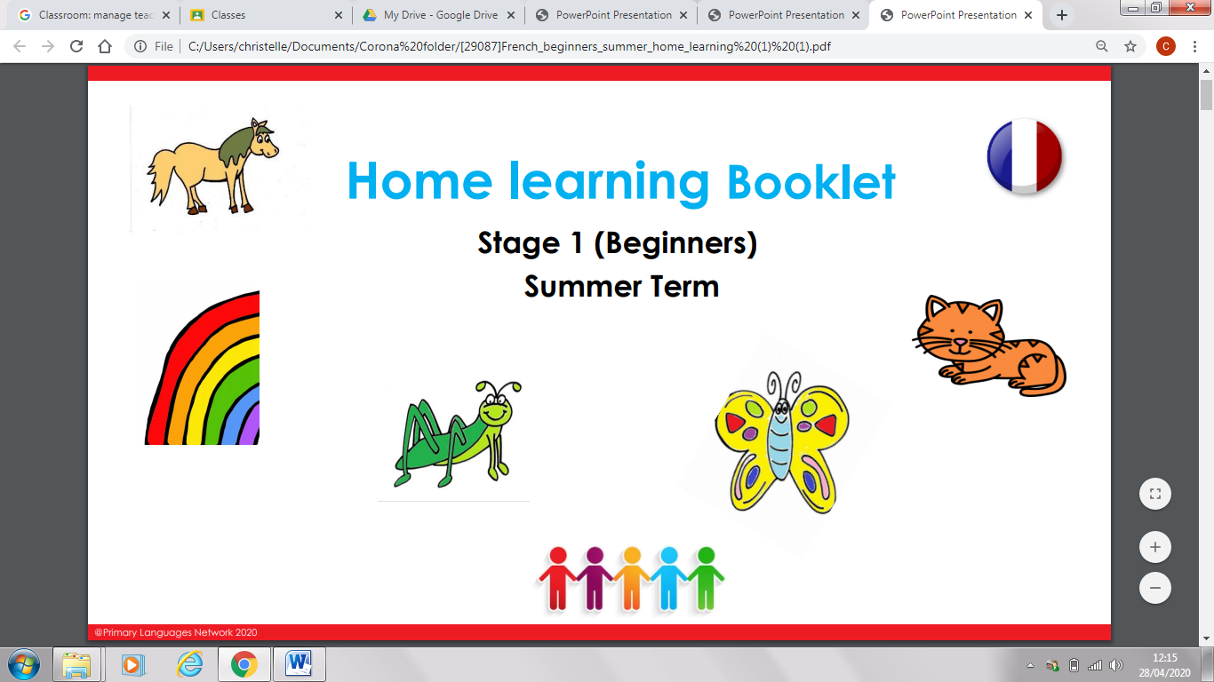Week 4- Rainbow writing. Sort out the word snakes.

Week 5- French school and characters

Week 6- Time capsule- all about me

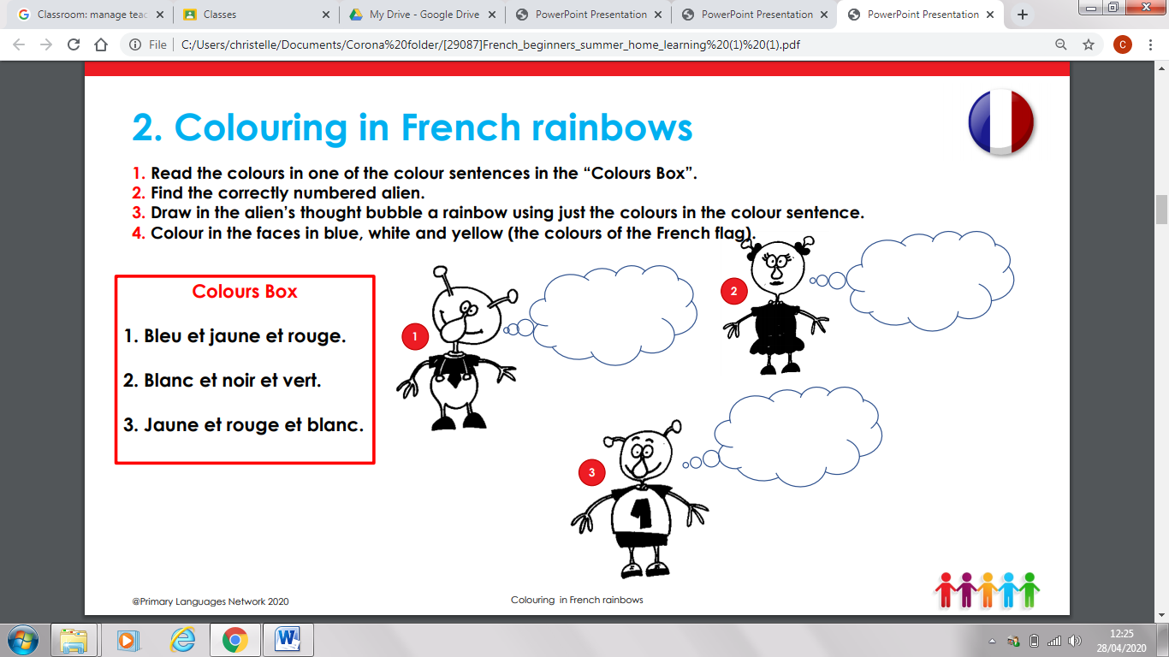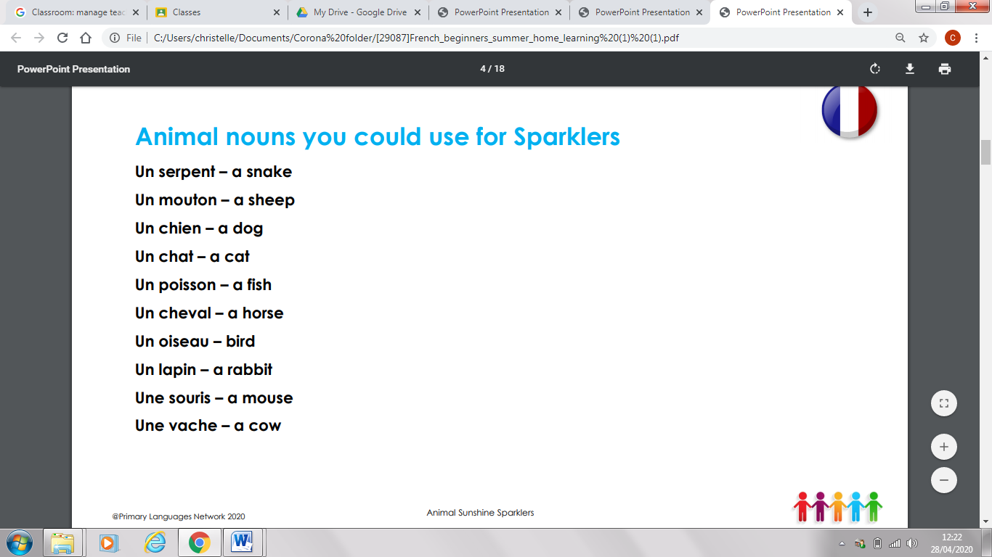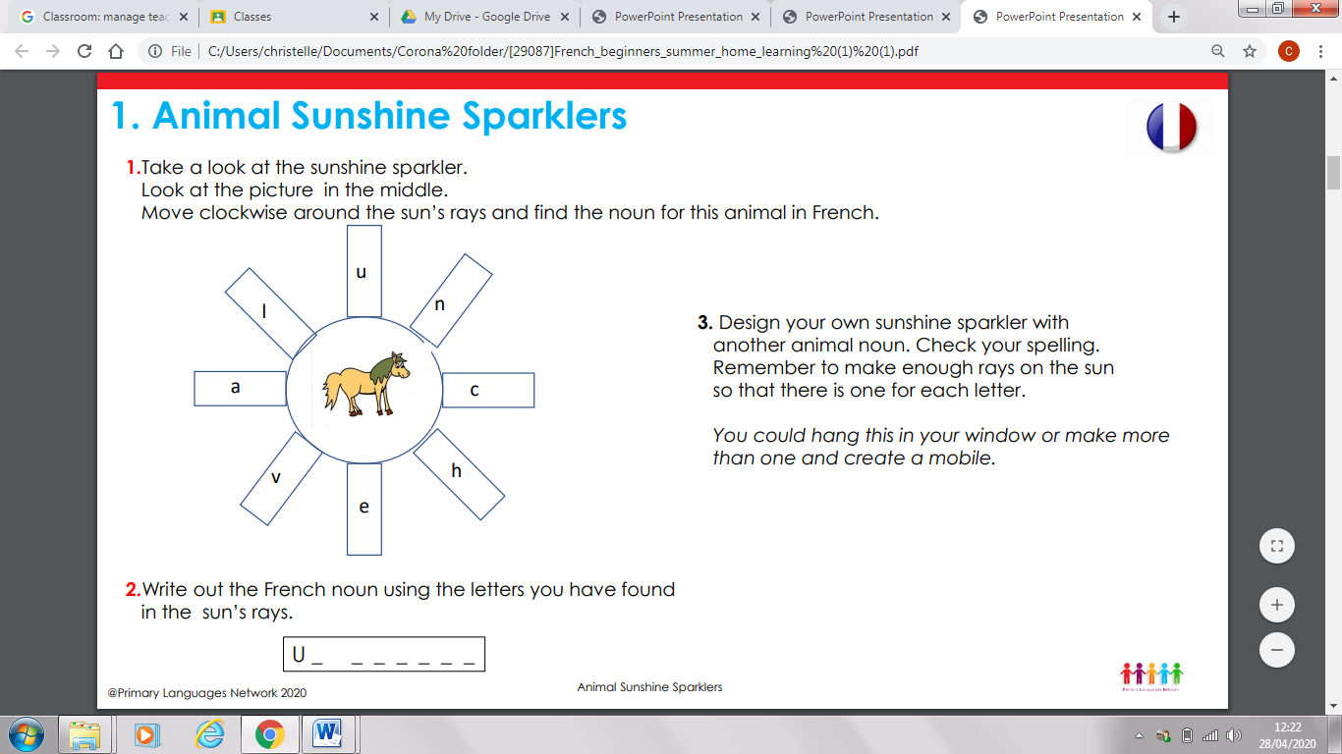Week 1

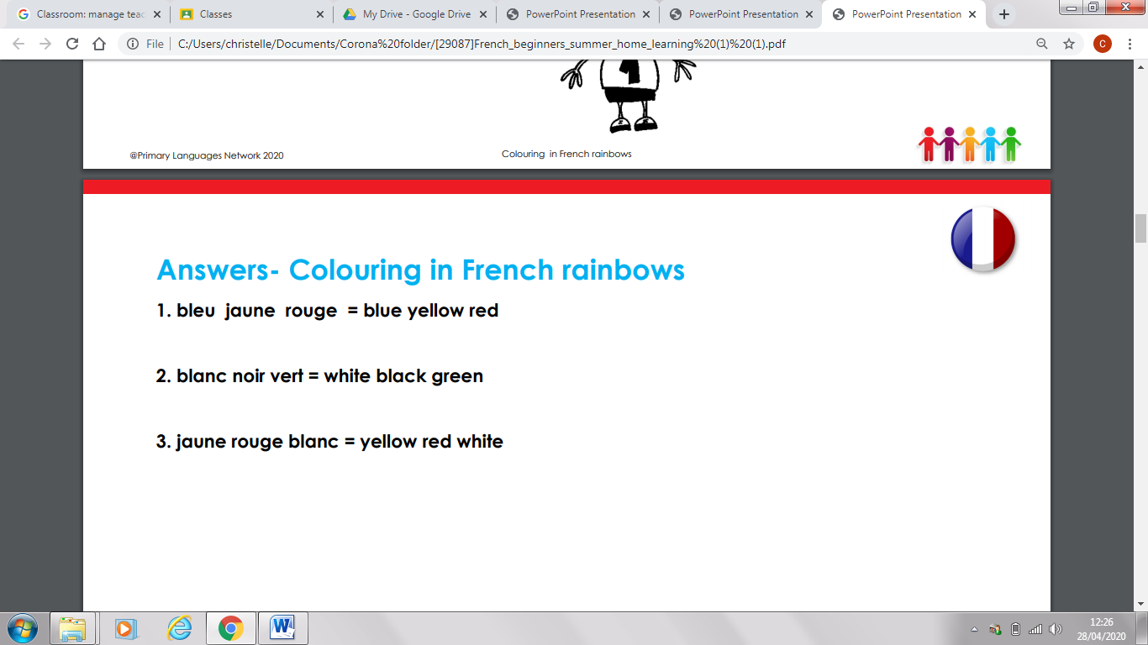

Week 1 -

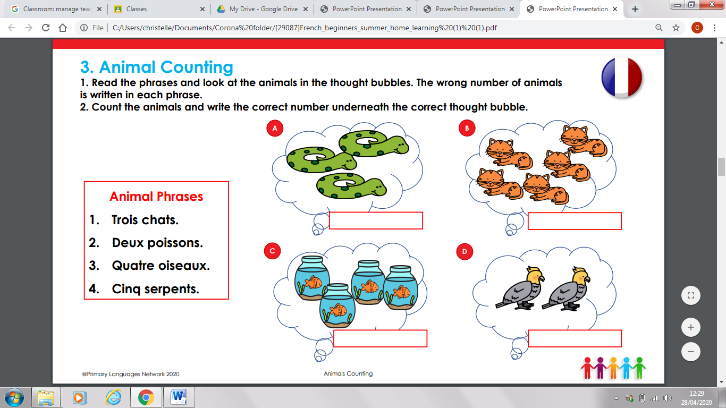Week 2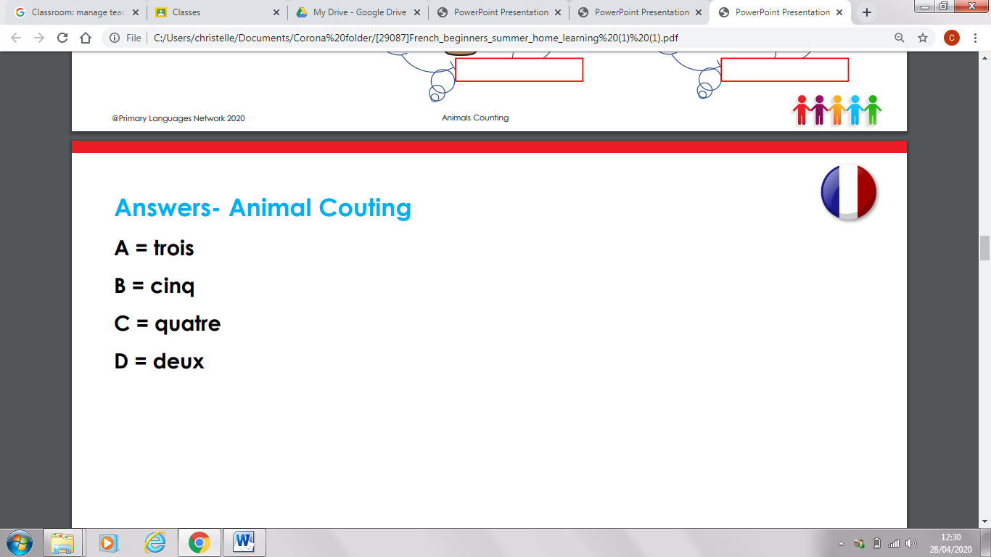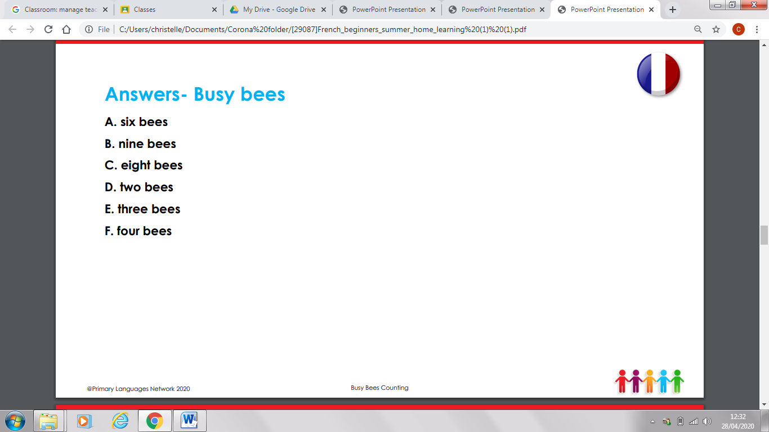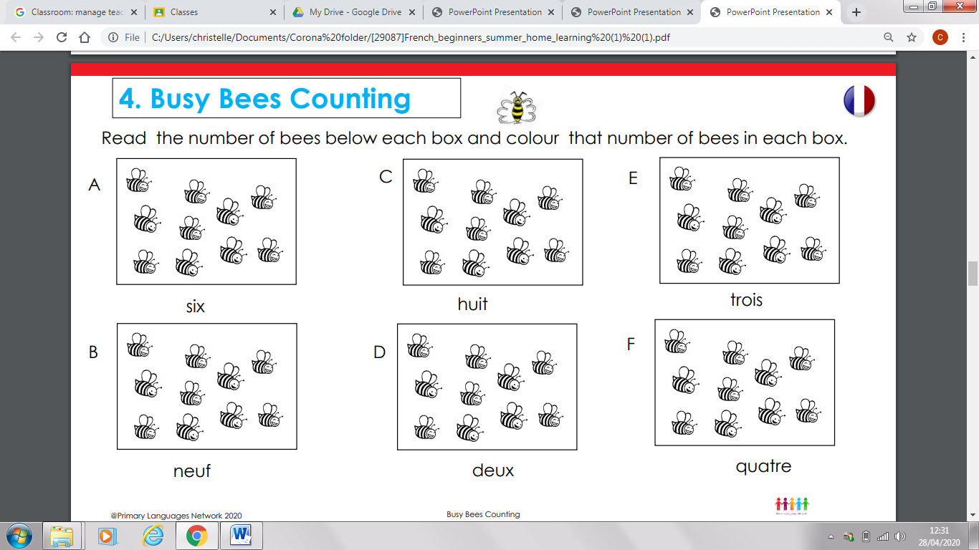

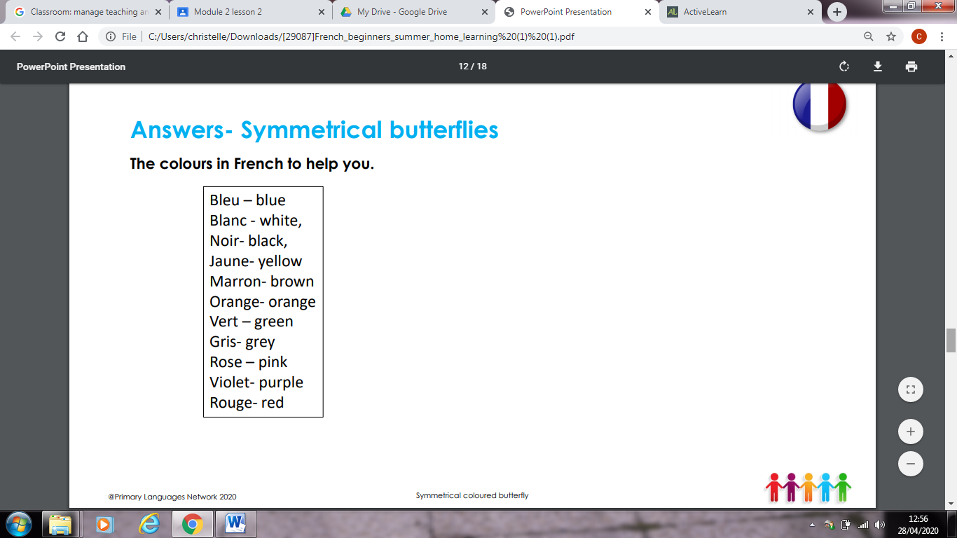Week 3

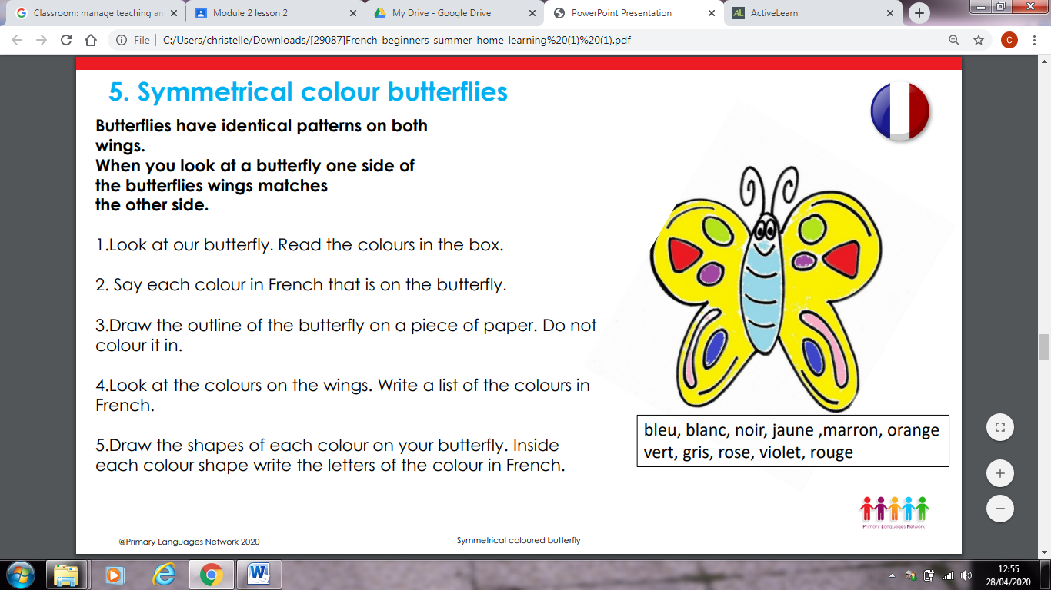

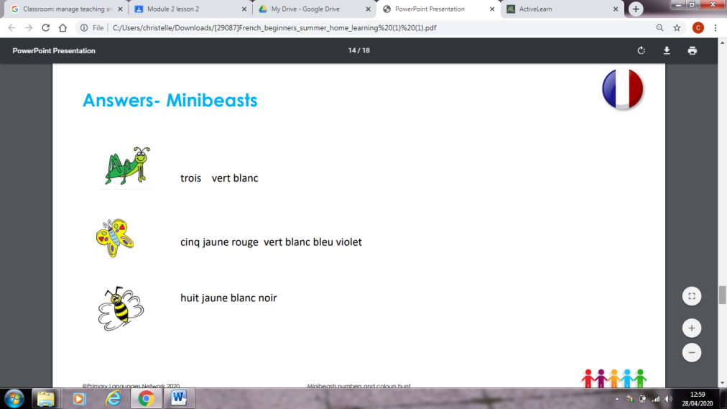

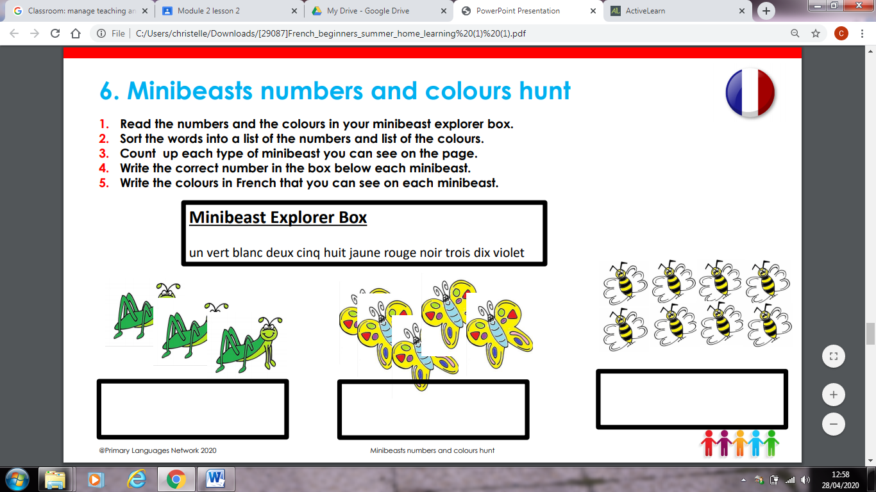

Week 4

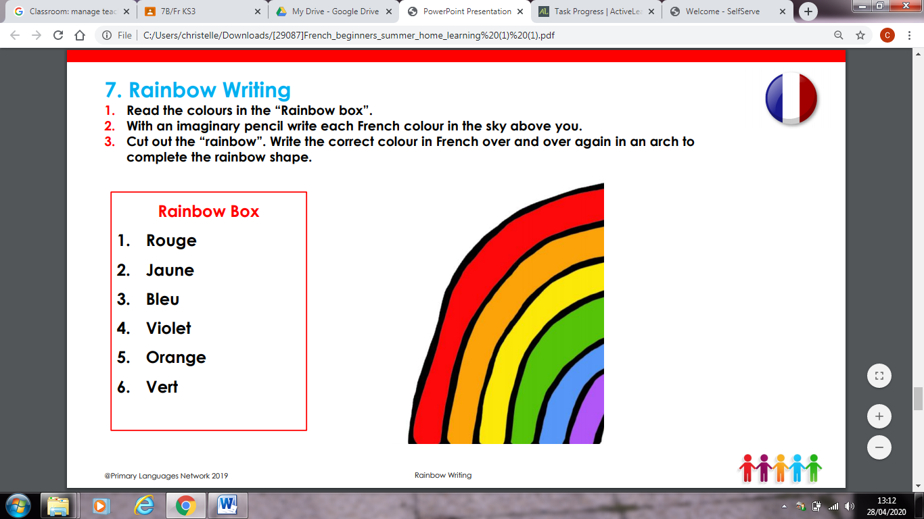

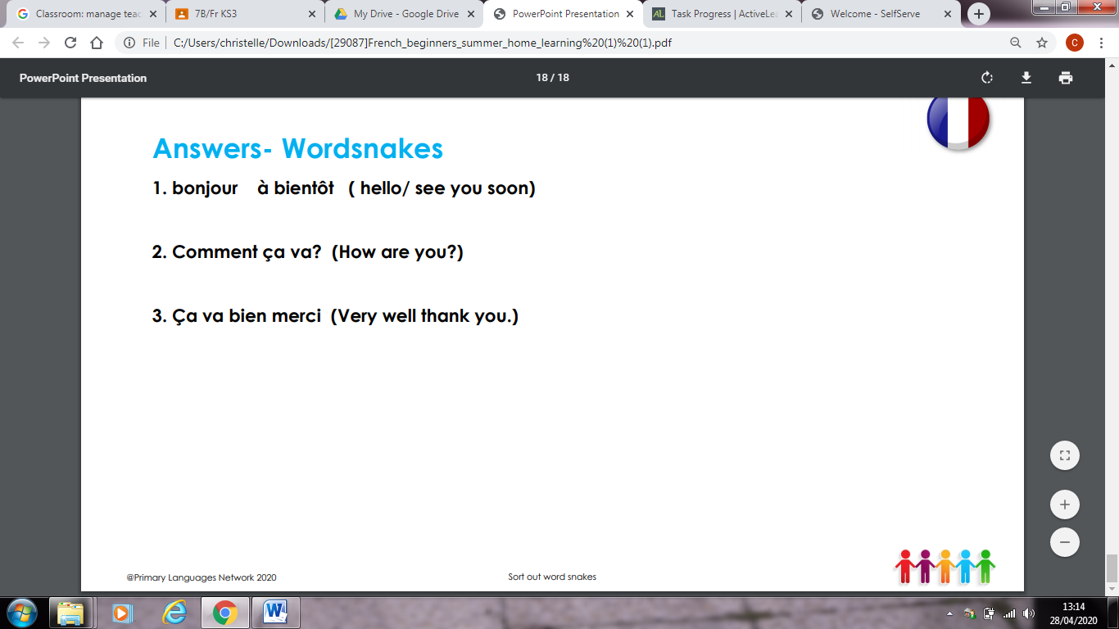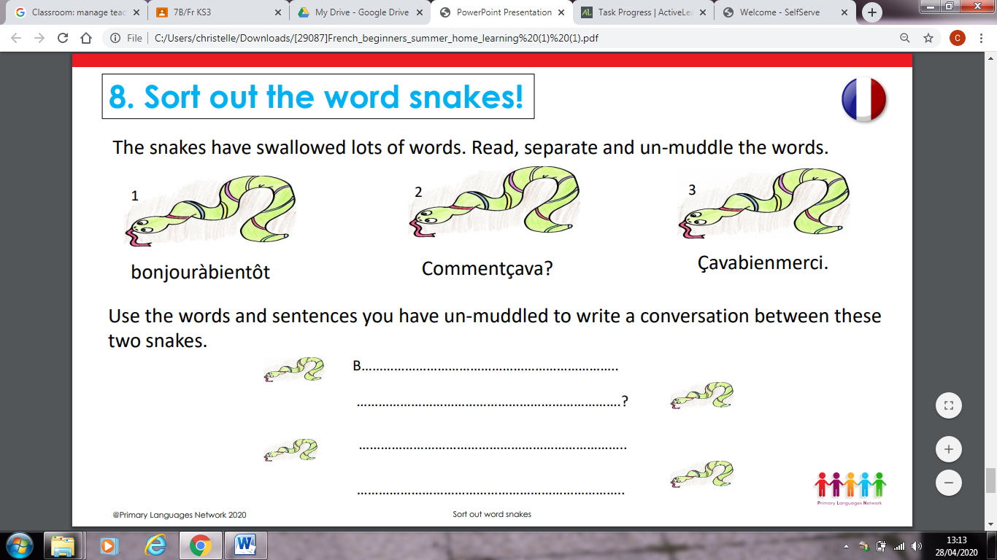

Week 5

Life in a French school

School is compulsory in France between the ages of six to sixteen.

Schools are divided between primary and secondary, as in the UK and there are also private and state schools.

French students go to school from Monday to Friday with Wednesday afternoon off. The school day is generally longer than in the UK but the holidays are longer. Lessons usually start around 8.30 in the morning. Pupils have at least one hour and a half for lunch and usually finish school around 16.30. French students typically don't wear a uniform.

Primary school

Nursery school is called “l'école maternelle” and takes children from two to six years old. Primary school is called “l'école primaire” and is for children aged six to eleven.

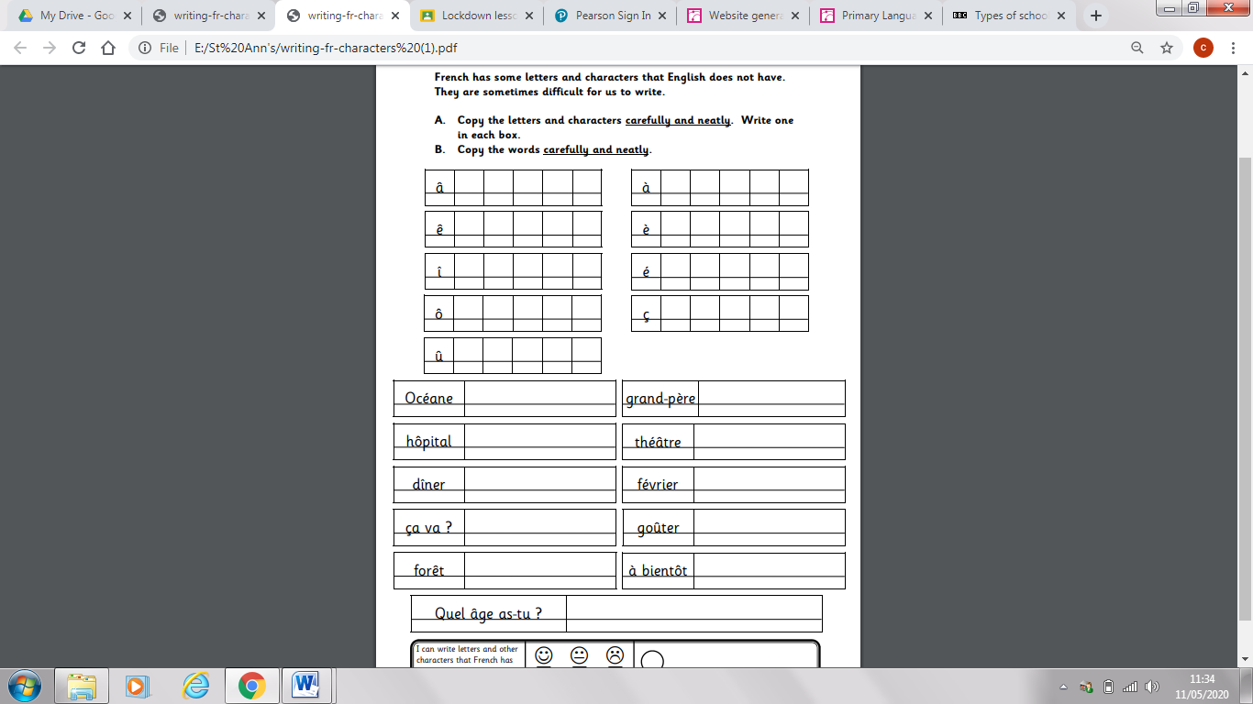

Week 6

