
Newsletter Issue 27: Friday 17 April 2026


St Ann’s Church of England
Primary School

Together, we aim high; with God’s love, we can fly!

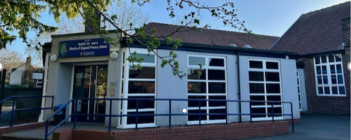

Y3 WATERSIDE VISIT

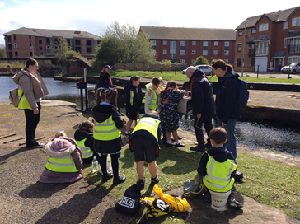
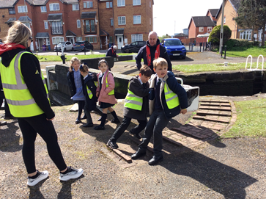
Year 3 children enjoyed a memorable waterside visit to Stanley Locks and Collingwood Docks, where they had the exciting opportunity to learn about how locks work and why they are important for boats travelling along the waterways. The children worked together to help operate a lock, allowing a boat to pass through safely, which gave them a real hands-on understanding of the process. They also explored the history of the docks and discovered how they were used in the past. As part of their visit, they completed a scavenger hunt that helped them observe their surroundings closely and learn in a fun, active way. The workers praised the children for their excellent manners, enthusiasm, and positive attitude throughout the trip, making it a very successful and enjoyable learning experience.

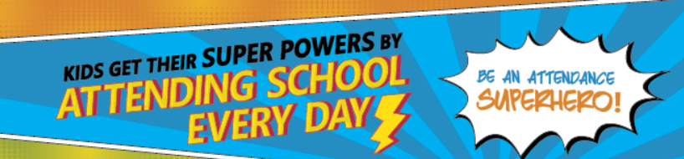

Attendance Expectations
Children are expected to be in school every day unless they are unwell. All other reasons will be unauthorised. If your child is going to be absent, contact school and let us know before 9.25am. Children not in school may receive a phone call home or home visit. In line we our Attendance Policy, we are committed to supporting families in improving their child’s attendance, before taking legal action.

Whole school attendance  year to date  Whole School target 96% | 96.2%
Whole school attendance  week ending 27th March 2026 | 96.16%
Class with best weekly attendance | 1T – 98.67%

#EveryMomentMatters
Number of pupils with 100% attendance this week
363

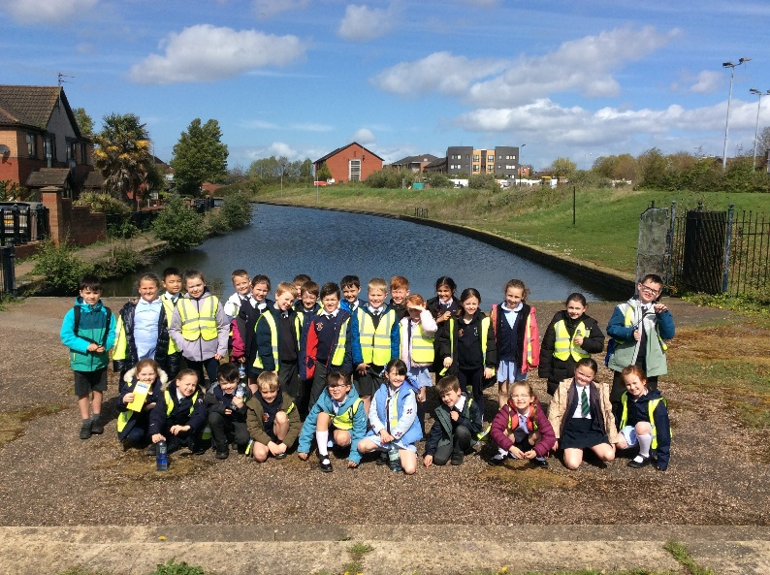

Punctuality
School gates open at 8.40am
School gates close at 8.50am
School starts at 8.50am

Children arriving after 8.50am will need to use the main entrance. Children who enter school via the main entrance will be registered as late. Regularly missing the beginning of lessons has a negative impact on a child’s progress and wellbeing.

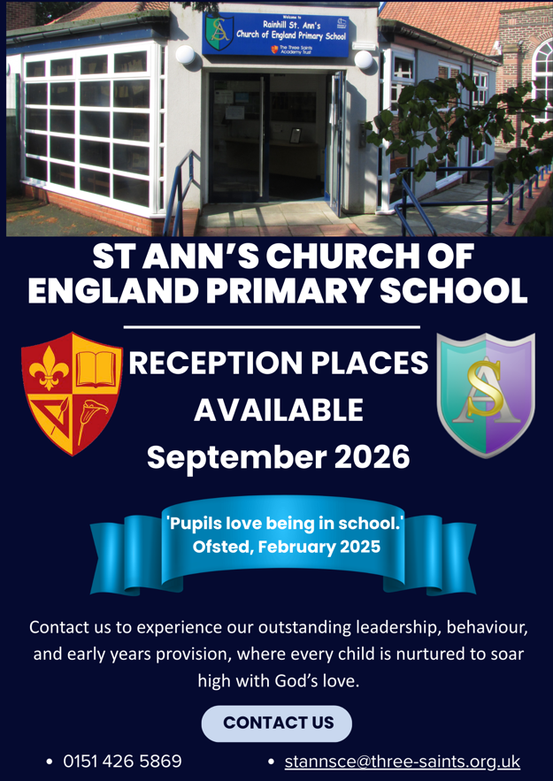

A SPOTLIGHT ON:
HISTORY


At St Ann’s Primary School, our history curriculum is carefully designed to provide a rich and well-rounded education. It helps pupils develop a strong understanding of chronology, both within Britain and across the wider world. We aim for every child to leave with secure knowledge of important historical periods, influential individuals and how past events continue to shape life today. We also encourage curiosity and an understanding that history can be viewed and interpreted in different ways.
Our curriculum is delivered through a clear, progressive structure from Early Years through to Year 6. Learning begins with children exploring their own lives and personal history, gradually expanding to wider historical contexts. This approach helps pupils build a connected and meaningful understanding of the past.

Curriculum Overview by Year Group
- EYFS: Personal experiences, family history, and significant life events
- Year 1: The 1960s (including Ruby Bridges, The Beatles and the Moon Landing)
- Year 2: The Victorians and the Great Fire of London
- Year 3: British monarchs (including William the Conqueror and Henry VIII)
- Year 4: Benin Kingdom, Anglo-Saxons and Vikings
- Year 5: Ancient Greece and the Roman Empire
- Year 6: Stone Age Britain and Ancient Egypt


Bringing History to Life
A key feature of our curriculum is History Week, an annual event that deepens pupils’ engagement with historical themes. Each year, children explore topics such as the local history of Rainhill or significant global events like World War II. Through hands-on activities and visits to local heritage sites, pupils gain a deeper and more meaningful understanding of history.

Some classes focus on local studies, helping children appreciate their community’s past and its place within a wider historical narrative. Others investigate major global events, examining their impact on people’s lives and society at the time. History Week provides a valuable opportunity for pupils to connect with both local and national heritage, fostering a lasting appreciation for the people and events that have shaped the world they live in today.


SAFEGUARDING ALERT

Separation and divorce

How to help children deal with divorce or separation?
Separation may involve bad feelings between the parents and their families. Children can pick up on this, which may make them confused or unhappy – or even blame themselves for a break-up.
To support children during a separation and help them with their worries, you should:
- remind them that they're loved by both parents
- be honest when talking about it but keep in mind the child's age and understanding
- avoid blame and don't share any negative feelings the adults have about each other
- keep up routines such as going to school and specific meal times and try and work together as parents to ensure routine is consistent for the child/children.
- let them know they can talk about their feelings with you – explain that it's okay to be sad, confused or angry and remind them of trusted adults in school they can talk to.

Please contact school should you wish to seek further support and guidance.

Y1 FOOTBALL COMPETITION

A team of enthusiastic Year 1 pupils proudly represented school at a local football competition this week, finishing in an impressive second place. The squad was thoughtfully made up of a mix of experienced young players and children who are new to the game, creating a balanced and supportive team environment.

Throughout the tournament, the children demonstrated excellent teamwork, determination, and sportsmanship, improving with each match they played. Staff praised the group not only for their achievement on the pitch but also for the way they encouraged one another, making the experience enjoyable for everyone involved. Well done Year 1!

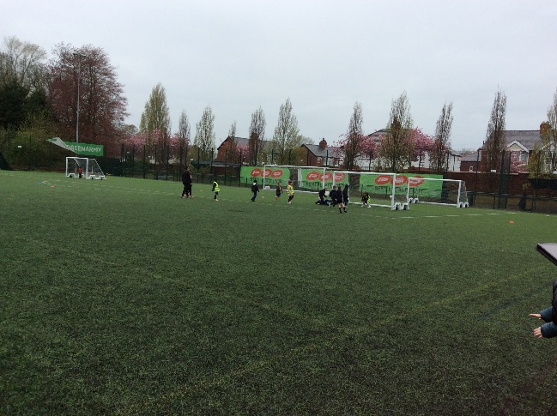


PARENT FORUM    The next Parent Forum for Parent Representatives will take place on Thursday 30 April at 2:00pm.  This meeting is an opportunity for parent reps to share feedback, discuss ideas, and strengthen communication between parents and the school. We look forward to your participation and valuable contributions. | FAMILY WORSHIP    Our next Family Worship will be led by 1S and take place on Friday 1 May at 9am. Please enter the hall via the back door.  Everyone welcome
Y4 PGL TO BOREATTON PARK  We are really looking forward to this year's PGL trip.  Please refer to the email previously sent for full details, including the kit list, food and sleeping arrangements.  The coach is due to arrive at 9:30am and we aim to depart before 10am. You’re very welcome to come and wave us off!  A reminder that no snacks should be brought due to allergies. Children should also not bring any electronic devices.  Thank you for your support – it’s going to be a fantastic trip!   | ST GEORGE’S DAY    On St. George's Day, Thursday April 23rd, children who are members of the Scouting movement are invited to wear their Scouting uniforms to school.  Only the following uniforms are permitted: Rainbows, Brownies, Guides, Beavers, Cubs, and Scouts. No other club uniforms are permitted.  Thank you for your cooperation!
SCHOOL NURSE DROP IN



Tuesday 21 April 8.30am
Y6 SATs WEEK  This year, Y6 SATs week will commence on Monday 11 May. The timetable below shows the statutory tests that all children will undertake. It is essential that your child is well rested before this week so that they have the greatest chance of achieving their potential. During the week please itself, ensure your child goes to bed at an age appropriate time and is off devices at least 1 hour before bedtime. Children must be in school each day and on time as the tests start first thing each day. Please make sure your child eats breakfast before leaving the house. Should you have any concerns, please do not hesitate to speak with your child’s class teacher.  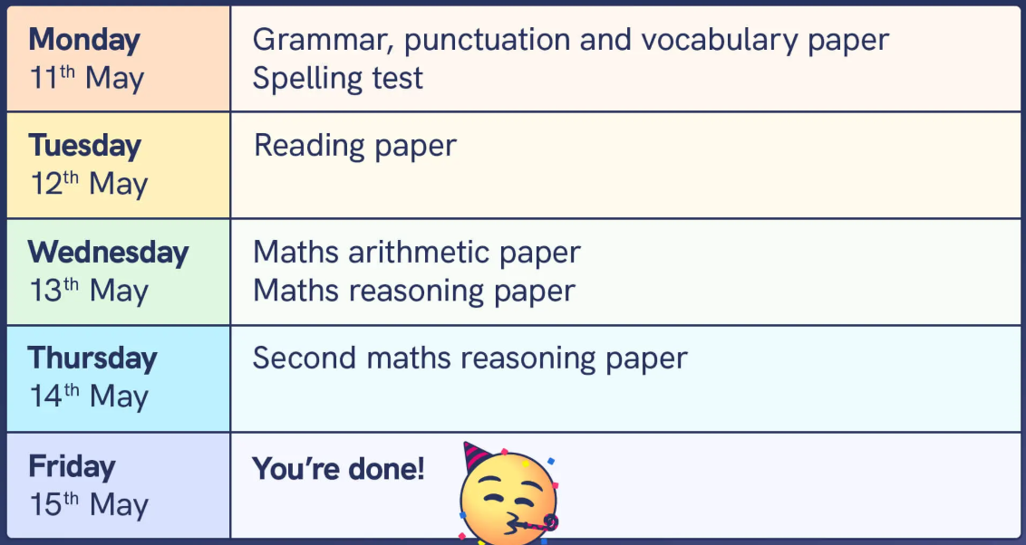  Parents will be given their child’s scaled score and whether they have reached the expected standard set by the Department for Education (‘NS’ means that the expected standard was not achieved and ‘AS’ means the expected standard was achieved).  The range of scaled scores available for each KS2 test is:  - 80 (the lowest scaled score that can be awarded)  - 120 (the highest scaled score)  The expected standard for each test is a scaled score of 100 or more. If a child is awarded a scaled score of 99 or less they won't have achieved the expected standard in the test. The Department for Education expects at least 65 per cent of children to reach the expected standard. | Y2 SATS  Y2 SATs will take place during the month of June during our whole school assessment week. As Y2 SATs are non-statutory, schools are free to manage the timetable and administration so that they are completed in a low-stress, low-key, age appropriate way; some children won’t even be aware they’ve taken them!  Children will complete the following tests:  KS1 reading  The reading test for Y2 is made up of two separate papers: Paper 1 is a selection of texts totalling 400 to 700 words, with questions interspersed. Paper 2 is a reading booklet with a selection of passages totalling 800 to 1100 words. Children write their answers in a separate booklet. Each paper should take around 30 minutes, but children are not strictly timed, as the tests are not intended to assess children’s ability to work at speed. The texts in the reading papers cover a range of fiction, non-fiction and poetry, and get progressively more difficult towards the end of the test. Teachers have the option to stop the test at any point that they feel is appropriate for a particular child.  KS1 maths  The Y2 maths test is made up of two papers: Paper 1 (arithmetic, worth 25 marks and taking around 15 minutes) and Paper 2 (problem-solving and reasoning, worth 35 marks and taking 35 minutes, with a break if necessary). Question types include multiple choice.  In order for children to achieve their potential it is important that children are having an age appropriate amount of sleep and are off devices at least 1 hour before bedtime. Please also ensure that your child eats breakfast before school each day.
PSHE & RSHE POLICY CONSULTATION

We have reviewed and updated our PSHE (Personal, Social, Health & Economic) and RSHE (Relationships, Sex & Health Education) policy to ensure it aligns with the latest statutory guidance. The updated policy has been emailed to you for your information.

Consultation period
· The policy is now out for parental consultation until Tuesday 28 April 2026.

· Please send any feedback or comments to stannsce@three-saints.org.uk by that date.

How we will share and discuss the policy
· The updated policy will be an agenda item at the next Parent Forum. Please share any feedback you may have with the class Parent Forum Rep. Our next Parent Forum Meeting for Reps is on Thursday 30 April.

· We will hold RSHE workshops for parents of children in Years 1–6 in the week commencing 18 May 2026. These sessions will share the content and materials we use in RSHE lessons and give you the opportunity to ask questions.

Why your feedback matters
We are committed to ensuring our RSHE curriculum is developmentally appropriate for our children, accessible to all, and supportive of their wellbeing. Your views help us make sure the policy and lessons meet the needs of our school community.

Thank you for taking the time to read the policy and for any feedback you provide.

CONGRATULATIONS
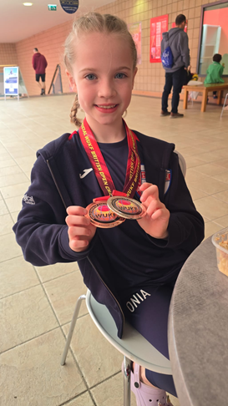

Massive congratulations to Onia in Year 4 who has recently competed in two Karate competitions gaining excellent results. She won two gold medals with trophies and one silver medal at a competition in Warrington.

She also competed in a competition in Crawley before half term where she won a silver medal becoming the highest scoring British competitor in her age category and a bronze medal.

Well done Onia!

BOOK FAIR

We are happy to announce that the Scholastic Book Fair will take place in the first and second week back between Thursday 16th April and Tuesday 21st April. . During this week children will be able to attend and purchase a book of their choice. Books range in price from £2 to £15.

Each class has been assigned a day and time to visit the book fair. If you would like your child to purchase a book please could they bring in their money on their assigned day. Children should bring money for the event in a named envelope and pass this to their class teacher.
In previous years, your generous purchases have not only provided children with new reading experiences at home but have generated significant funds for school to purchase additional books for our class libraries. We have really appreciated your support with this event in the past and hope with your help we can provide even more reading experiences for our pupils. Happy Reading!

Date to Visit Book Fair | Class
Thursday 16th April | Year 4
Friday 17th April | Year 1 and Year 2
Friday 17th April | Year 6
Monday 20th April | EYFS
Monday 20th April | Year 5
Tuesday 21st April | Year 3



SPORTS DAYS

Please find detailed below the dates and time for this year’s Sports Days (weather permitting). If sports days need to be cancelled due to inclement weather, we will send out a message as soon as possible.

YEAR GROUP | DATE | TIME | RESERVE DAY
EYs | Tuesday 19 May | 1.30-3.00pm | Tuesday 2 June
Y1 | Tuesday 19 May | 9.15-10.15am | Tuesday 2 June
Y2 | Tuesday 19 May | 10.30-11.30am | Tuesday 2 June
Y3 | Wednesday 20 May | 9.15-10.15am | Wednesday 3 June
Y4 | Wednesday 20 May | 10.30-11.30am | Wednesday 3 June
Y5 | Wednesday 20 May | 1.00-2.00pm | Wednesday 3 June
Y6 | Wednesday 20 May | 2.00-3.00pm | Wednesday 3 June

NEW: HOMEWORK ACTIVITIES TO NURTURE YOUR CHILD’S SPIRITUAL GROWTH

This week we’re launching short weekly spirituality tasks to support your child’s wellbeing. Why not have a go at this week’s activity?

Quiet minute of wonder — 1–3 mins
  - EYFS: “Look out at the sky. What do you see? Can you point to the biggest thing?”
  - KS1: “What one thing out there makes you go ‘wow’? Why?”
  - KS2: “What about that scene surprised you? Why does it make you feel amazed?”
Tip: Sit by a window before bedtime; keep it short and sensory.
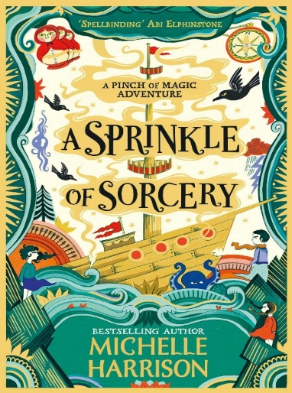

RECOMMENDED READS

A Sprinkle of Sorcery
By Michelle Harrison

Recommended for 8-12 year olds
I would recommend A Sprinkle of Sorcery because it follows the Widdershins sisters — Betty, Fliss, and Charlie — who are trapped on the misty Isle of Crowstone after breaking the rules that protect them from a dangerous family curse. When their stepmother is wrongly accused of a terrible crime, the girls must set sail on a risky journey to prove her innocence.
Armed with a suitcase full of magical objects, they face smugglers, secrets, and dark magic. Along the way, the sisters learn to trust one another, confront their fears, and discover that courage and loyalty are the strongest magic of all.
Happy reading! Mr Evans

Family of Faith


A Reflection from Miss Stone  Hebrews 6:10 reminds us that God is just and never forgets the love we show through serving others. Every act of kindness—whether small or great—is seen and valued by Him. This connects closely to the Christian value of service, where helping others becomes an expression of our faith and love for God.  Service is more than duty; it is a way of living out God’s love. When we support those in need or care for others, we reflect His character. Even when our efforts go unnoticed by people, God remembers them.  This verse encourages us to keep serving faithfully. It reassures us that our work has purpose and eternal value. By continuing to serve others with love, we grow spiritually and demonstrate a genuine commitment to God. |  | Our Christian Value this half term is…  JUSTICE  God is not unjust; he will not forget your work and the love you have shown him as you have helped his people and continue to help them  Hebrew 6:10
St Ann’s Church Services  8:30am Sundays: Traditional Book of Common Prayer Holy Communion in Church. All welcome.  10:30am First Sunday: All Together For Worship – lively, inclusive parish service in Church.  10:30am Other Sundays:  - 2nd Sunday: Common Worship Communion (lighter service)  - 3rd Sunday: Morning Prayer and Teaching  - 4th Sunday: Formal Eucharist  (All in Church, concurrent with Platform 2)  10:30am Weekly (except 1st Sunday): Platform 2 in Millennium Centre – informal, family-focused worship with group activities, crafts, and games. Coffee and refreshments provided.  Thursdays 9:30am: Midweek Holy Communion in Church, followed by coffee in the Centre. |  | 
GENERAL INFORMATION/ REMINDERS

SCHOOL UNIFORM REMINDERS  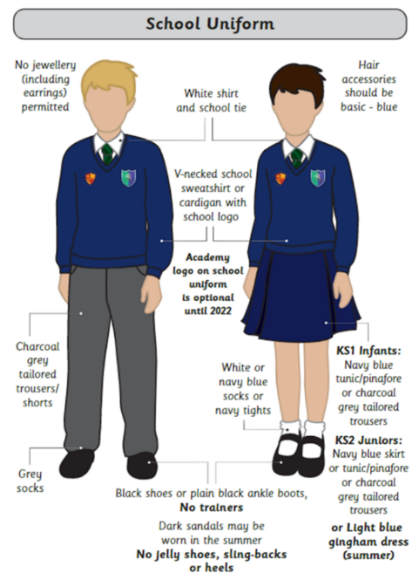  *Please note, it is not compulsory to wear items of clothing with the school and Trust logos on. Children may wear plain navy-blue items of school uniform. | SCHOOL SHOES REMINDER  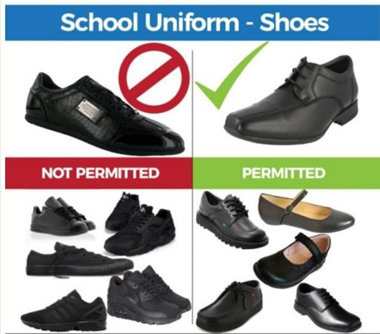
INDIVIDUAL HEALTH CARE PLANS

If you have notified school that your child has a medical condition that requires an Individual Health Care Plan please ensure that if there are any changes to their condition a new form is completed.

If your child has a newly diagnosed condition that requires an Individual Health Care Plan please contact the school office to arrange for a form to be completed.

CONTACT DETAILS, CONSENT & PERMISSIONS

On a regular basis please check your contact details, consent and permissions on Arbor to make sure
they are up to date for your child. Thank you

SCHOOL MEAL MENU

For a copy of the most up to date school meals menu, please check out our website by clicking on the following link: https://www.rainhillstanns.co.uk/page/?title=School+Dinner+Menu&pid=46

Please note, the menu is subject to change where there is a shortage of supplies.

TOAST

The deadline for toast for this half term has now passed. Please see below for details of the payments required for future half terms.

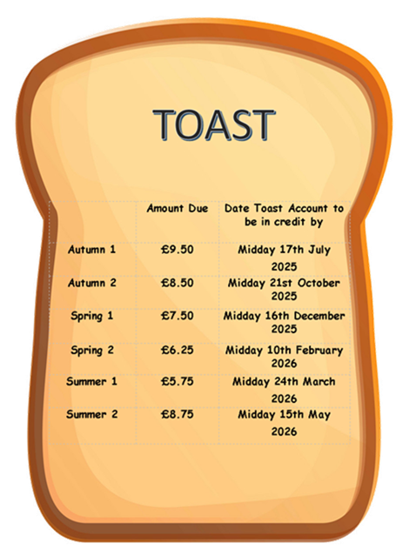
PURCHASING SCHOOL ITEMS

If you wish to purchase a school item this can now be done through Arbor. If you make a purchase please email the school office at stannsce@three-saints.org.uk so that arrangements can be made to issue the item. Current prices are as follows:

School Bag £10.00, Junior Tie £4.00, Elasticated Tie £3.50

OFFICE HOURS

We kindly ask for your patience and support during a period of reduced capacity in our school office. Please note that the office will close at 3:30pm each day until further notice. During this time, responses to calls and emails may take a little longer than usual, and we appreciate your understanding as we do our best to assist everyone. Thank you for your continued cooperation and support.

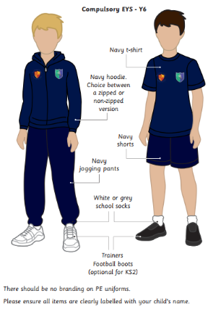
PE KIT EXPECTATIONS

At St Ann’s, children wear their PE kit to school on the days they have PE lessons. We view the PE kit as an important extension of our school uniform, and therefore, we expect the same high standards of dress to be maintained.

All children are required to wear:

- Navy blue t-shirt
- Navy blue hoody
- Navy blue shorts
- Navy blue jogging bottoms
- Trainers

These items can be plain or feature the school and Trust logo. Please note that branded sportswear is not permitted.

Additionally, trainers should only be worn on PE days and are not acceptable as everyday footwear.

If a child arrives without the correct PE kit, the school will provide suitable clothing for them to wear during the day.

We appreciate your continued cooperation and support in helping us uphold these standards.

TERM DATES 2025-26 | Easter Bank Holidays:  Good Friday: 3 April 2026  Easter Monday: 6 April  Bank Holidays during term time:  Monday 4 May 2026  Inset Days:  1 September 2025  2 September 2025  21 November 2025  22 May 2026  20 July 2026
  Term | Open on | Close on
  Autumn Term 2025 | Wednesday 3 September 2025 | Friday 24 October 2025
  Autumn Term 2025 | Monday 3 November 2025 | Friday 19 December 2025
  Spring  Term 2026 | Monday 5 January 2026 | Friday 13 February 2026
  Spring  Term 2026 | Monday 23 February 2026 | Friday 27 March 2026
  Summer Term 2026 | Monday 13 April 2026 | Thursday 21 May 2026
  Summer Term 2026 | Monday 1 June 2026 | Friday 17 July 2026
Courtesy  Care  Concentration | St. Ann’s Church of England Primary School  View Road, Rainhill, Merseyside, L35 0LQ  Tele: 0151 426 5869  Website: http://www.rainhillstanns.co.uk  Email: stannsce@three-saints.org.uk  Instagram: stanns_ttsat  Headteacher: Mrs Laura Rynn

‘But those who trust in the Lord, they will find new strength.
They will soar high on wings like eagles’ Isaiah 40:31

Parents’ Suggestion/Comment Slip



